C3 Project: Restaurant Finder: Part 1

Usecase Diagram

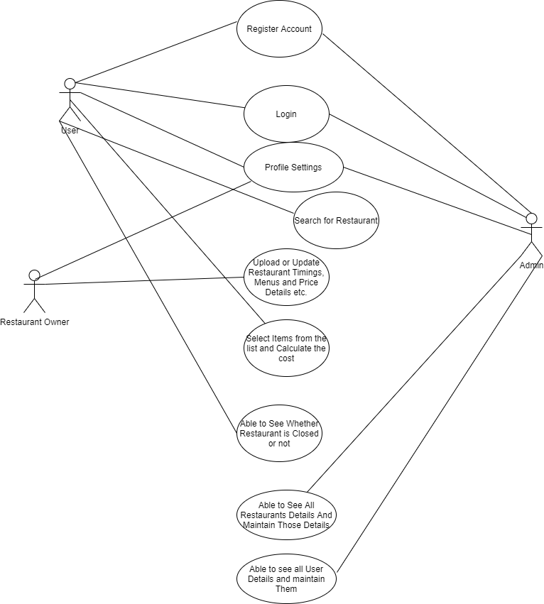

User Activity Diagram

